Separating Innovation from Mechanical Writing: How Humans and AI Can Collaborate on Technical Writing to Maximize Efficiency

Vəhid Gəruslu
Queen’s University Belfast, Belfast United Kingdom
v.garousi@qub.ac.uk
Azerbaijan Technical University, Baku, Azerbaijan
vahid.garousi@aztu.edu.az
ORCID: 000-0001-6590-7576

Abstract:
Use this term: AI-Assisted Technical Writing

Keywords: Start…

Table of Contents
1 Introduction 2
2 Background and Related Work 2
2.1 Emergence of AI and its Use in Different Research Activities 2
2.2 Growing Literature on AI Use in Academic and Technical Writing 2
2.3 AI-o-phobia and Ideas of Banning AI Use in Research Writing 3
2.4 Existing Dedicated AI Tools for Supporting Academic Writing and Research in General 3
3 Research Approach 3
4 Separating Innovation from Mechanical Writing: A Spectrum of Collaboration Modes 4
4.1 The Spectrum: Five Levels of Maturity 4
4.2 Mental Models and Metaphors 6
4.2.1 The 80/20 Rule: Strategic vs. Routine Work 6
4.2.2 A Best Practice: AI-assisted Top-Down Writing 6
4.3 Human-AI Collaborative Workflow 9
4.4 Transparency and Ethical Guidelines 10
5 Illustrative Applications of the Framework 10
5.1 Overview of Illustrative Papers 10
5.2 Individual Case Insights 11
5.2.1 Paper P1: Fault Tolerance for Model-Based Software Testing 11
5.2.2 Paper P2: Hidden Costs of AI-Assisted Software Engineering 11
5.2.3 Paper P3: Reunification Viability of two Divided Parts of Azerbaijan 11
5.2.4 Paper P4: Factors Influencing the Quality of AI-Generated Code 11
5.2.5 Paper P5: Developing a Causal Model for Quality of Higher Education System 11
5.2.6 Paper P6: The Current Paper 11
5.3 Cross-Paper Patterns and Learnings 12
5.3.1 Speed and Integrity: Efficiency Gains Within Ethical Research Guidelines 12
5.3.2 The Learning Curve: Efficiency Gains Across Papers P1–P5 12
5.3.3 The Multi-Author Challenge: Coordination and Consistency 12
6 Discussions and Implications 12
6.1 Limitations 12
6.2 Implications 12
7 Conclusions 12
Acknowledgements 12
References 12
Appendix A-Example Noteworthy Interactions with AI 14
Asking AI to Review the Paper Structure Drafted by The Researchers for the Case Paper P6 (The Current Paper) 14

Introduction
Context: …
Discuss this Nature paper: How much of the scientific literature is generated by AI? (Naddaf, 2026) https://www.nature.com/articles/d41586-025-03504-8
Discuss this grey literature blog: “More Articles Are Now Created by AI Than Humans” https://graphite.io/five-percent/ai-now-writes-as-many-online-articles-as-humans-do
Like “Vibe-coding”, we can call these: “Vibe-research” and “Vibe-writing”.. more precisely, like AI-assisted Software Engineering, we can call these AI-assisted research and AI-assisted research writing.
Problem statement:
Lots of Growing Literature on ethical and responsible AI Use in research, and Academic and Technical Writing
Understanding and characterizing Spectrum and Modes of Collaboration between Human and AI in Research and Technical Writing is important since XXX (you tell me)
Contributions of this paper are X-fold:
- …

This article is structured as follows. ……..

Background and Related Work
Understanding human-AI collaboration in technical writing requires situating this work within two overlapping contexts: the broader adoption of AI across research activities, and the emerging literature specifically on AI's role in academic writing. This section reviews both landscapes, highlighting the tension between enthusiasm for AI-accelerated research and persistent concerns about its responsible use in scholarly communication.

Emergence of AI and its Use in Different Research Activities
AI adoption across research is accelerating. Research demonstrates that artificial intelligence is already contributing to scientific discovery across multiple domains (Hassabis, 2024).
A large-scale survey of over 6,000 researchers across two major German research organizations revealed that researchers actively employ AI in both core research activities and creative tasks (Chugunova et al., 2026). However, the same study identifies legal uncertainty as a significant barrier to broader adoption. Guidance on practical tool selection is emerging in the literature (Heidt, 2025), yet some academics remain reluctant to engage with generative AI altogether, citing concerns about authenticity and intellectual control (Docter-Loeb, 2026).
This background motivates the central question: if AI is being used widely but inconsistently in research activities, how should it be deployed specifically in technical writing—and how can researchers maintain intellectual integrity while doing so?

Growing Literature on AI Use in Academic and Technical Writing
A substantial body of work now examines AI's role in academic writing. Recent scholarship addresses multiple dimensions: questions of authorship and responsibility (Dere, 2023; Formosa et al., 2024), ethical frameworks for disclosure and use (Porsdam Mann et al., 2024), concerns about epistemic quality and rigor (Tang, 2025), and pedagogical guidance for responsible adoption (Winberg et al., 2024).
Research also documents practical concerns. Qualitative studies highlight researchers' ambivalence: enthusiasm for efficiency gains tempered by anxiety about authenticity and control (Dergaa et al., 2023). Legal and ethical barriers remain salient (Rentier, 2024), as do questions about how to evaluate and verify AI-assisted scholarly work.
Notably, no existing framework systematically characterizes the spectrum of collaboration modes in technical writing—i.e., the different levels of human oversight, control, and intellectual ownership that are possible and defensible. This gap motivates the present work.

AI-o-phobia and Ideas of Banning AI Use in Research Writing
Alongside adoption enthusiasm, significant resistance has emerged. Research documents widespread "AI-phobia"—anxiety about AI capabilities and consequences—particularly in academic and professional contexts (Lee & Park, 2023; Samuel et al., 2024). This concern manifests as fear that AI-generated text undermines authentic scholarly thinking and distorts research integrity (Samuel et al., 2025; Zhao et al., 2025).
These concerns have prompted institutional responses. Most notably, arXiv.org announced in 2026 that authors relying entirely on AI-generated text risk one-year bans from submission. The concern is concrete: poorly screened AI-generated papers ("AI slop") flood preprint servers, imposing review burden on human experts and obscuring high-quality research. Simultaneously, the emergence of tools designed to mask AI-generated text has alarmed researchers and editors, raising questions about authenticity and discoverability.
Yet anxiety about AI in writing coexists with legitimate philosophical concerns about authorship and intellectual ownership (Formosa et al., 2024). The central tension is unresolved: How can researchers leverage AI efficiency without surrendering intellectual ownership or compromising research integrity? This paper proposes a framework addressing precisely this tension—distinguishing responsible collaboration from problematic delegation.

Existing Dedicated AI Tools for Supporting Academic Writing and Research in General
General-purpose large language models (LLMs)—notably OpenAI's ChatGPT and Anthropic's Claude—have become accessible platforms for research support. However, specialized tools designed specifically for academic workflows offer domain-optimized alternatives.
- Literature Discovery & Search: Tools such as Consensus and Elicit provide evidence-based summaries from peer-reviewed literature. Research Rabbit visualizes citation networks, supporting systematic literature exploration.
- Data Analysis & Comprehension: Google NotebookLM, SciSpace, and Julius AI assist with PDF synthesis, quantitative analysis, and visualization—allowing researchers to extract insights from large document collections or datasets.
- Writing & Formatting: Specialized Word add-ins (Paperpal, Writefull, Ref-n-write) and standalone tools (Jenni AI, Thesify) support sentence-level refinement, academic phrasing, and citation management. Critically, some tools—notably Thesify—explicitly provide structural feedback without generating text, preserving human intellectual agency.
These tools span a spectrum: from general-purpose assistants to domain-specific instruments. The framework proposed in this paper applies across this spectrum, helping researchers calibrate their reliance on AI by collaboration level rather than tool category.

Research Approach
This paper combines deductive framework development with illustrative empirical grounding. The author drew on cumulative experience across 10+ papers employing AI assistance for research and/or writing activities, synthesizing patterns into a conceptual spectrum of collaboration modes (presented in Section 4).
Framework Development: The five-level maturity spectrum (Section 4.1) was developed inductively from observed practice across these papers, informed by the literature on responsible AI adoption (Section 2). The spectrum distinguishes collaboration modes by the degree of human oversight, control, and intellectual ownership retained by the researcher. Mental models supporting this framework—the 80/20 rule, pyramid metaphor, and driver/car analogy—emerged from reflection on actual workflows and were refined iteratively.
Empirical Grounding: The paper reports illustrative applications rather than a rigorous empirical study. Five published or currently-under-review papers (P1–P5) plus the current paper (P6) serve as case examples. For each, the author collected quantitative data: total writing effort (hours), number of prompts issued to AI, tools used (ChatGPT or Claude), and timeline. These metrics were extracted from word-processor logs and prompt histories and are reported in Section 5.1. Qualitative observations about collaboration patterns, researcher learning, and workflow challenges supplement quantitative data.
Scope and Limitations: Data collection focused on the author's own experience and single-author papers. This approach enables transparency and detailed documentation but limits generalizability. Multi-author workflows (Section 5.3.3) remain unexplored empirically and are flagged as future work.
Transparency and Artifacts: All empirical data, prompt logs, and iteration histories are archived in a public GitHub repository, enabling verification and reuse. This paper itself demonstrates Level 5 collaboration (Section 4.1), with the author providing research ideas, structure, and intellectual direction while Claude (Anthropic) assisted with drafting and refinement.

Separating Innovation from Mechanical Writing: A Spectrum of Collaboration Modes
The central challenge in human-AI collaboration is not whether AI should assist in writing, but how—at what level of human control, and with what degree of intellectual ownership retained by the researcher. This section presents a five-level maturity spectrum that distinguishes collaboration modes by the balance between human cognitive work (ideas, synthesis, judgment) and AI routine work (language, formatting, structure). Rather than an all-or-nothing choice between complete AI delegation and complete avoidance, the spectrum enables researchers to calibrate their use of AI assistance while maintaining intellectual integrity and transparency.

The Spectrum: Five Levels of Maturity
We propose the HAIRS (Human-AI Research-writing Spectrum) framework, a spectrum spanning from minimal AI engagement (surface proofreading) to deep collaboration (strategic orchestration). The framework is grounded in the principle that the researcher's cognitive labor should concentrate on innovation—ideas, evidence, synthesis, and conclusions—while AI handles mechanical aspects of writing: grammar, flow, formatting, and routine drafting.
The five levels reflect increasing sophistication in how humans and AI interact:
- Levels 1–2 represent inappropriate or minimal engagement: ghostwriting (learning only) and proofreading.
- Levels 3–4 represent appropriate intermediate collaboration: structural refinement and ideation support.
- Level 5 represents mature strategic collaboration: the researcher provides detailed intellectual direction; AI handles execution.
Progression across levels reflects two dimensions: (1) the degree of human cognitive ownership, and (2) the specificity and richness of human input. At Level 1, the human provides a single vague prompt and AI generates everything. At Level 5, the human supplies detailed research notes, literature summaries, and a pre-defined narrative structure; AI drafts and refines while the researcher retains strict control over "what" is said.

Appropriate? | Human Cognitive Ownership | Level | What it is | What the Human Provides / Owns | What AI Handles | Appropriate Use / Benefits | Disclosure Required
Inappropriate practice | 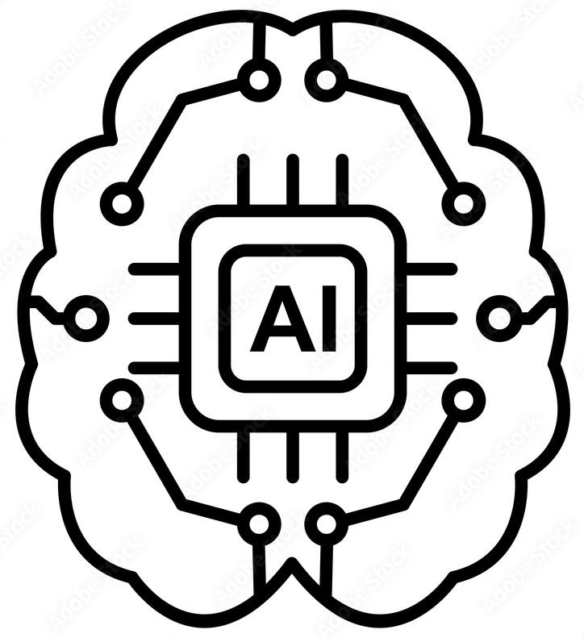  AI does all the writing | 1. Ghostwriting (Full Delegation) - not a true collaboration level | Prompting AI to write complete papers from scratch. Results in generic "AI slop" that lacks original insight, contains hallucinations, and risks academic integrity violations. | Only a single short vague prompt | Everything | Educational use only: generating sample drafts for junior researchers to study and learn scholarly writing conventions. Output must not be submitted for publication or public dissemination. | Not acceptable
Appropriate practice |  | 2- Proofreading & Grammar Polishing | Using AI as an advanced spellchecker or grammar guide to clean up human-written drafts. Sentence/word level (mechanics: spelling, grammar, word choice) | Drafting, ideas, structure | Grammar, fluency | Helps non-native English speakers or novice writers improve sentence-level fluency and grammatical accuracy. | Minor: "Edited with AI grammar tools"
Appropriate practice |  | 3- Structural Refinement & Style Enhancement (Intermediate) | Using AI to improve coherence, transitions, and adherence to specific journal or academic styles. Paragraph/section level (coherence: transitions, flow, argument structure) | Ideas, argument, evidence | Flow, transitions, style | Any researcher wanting clearer, more polished prose. Assists in reshaping paragraphs for better logical flow and tone without altering the core ideas, given by human. | "Structural editing with AI"
Appropriate practice |  | 4- Collaborative Ideation (Advanced) | Using AI to brainstorm angles, structure outlines, or provide feedback on the logical soundness of an argument. | Research questions, methodology, conclusions | Brainstorming, outlining, structural feedback | Working through unclear ideas; designing structure. Acts as a sounding board, helping researchers clarify their own thinking and identify missing sections in their research. | "AI assisted with outlining and ideation"
Appropriate practice |  | 5-Strategic Collaboration and Orchestration (Highly Mature) | Providing rigorous, highly tailored prompts containing researcher’s own exact research notes, specific literature, and a pre-defined narrative. | Ideas, synthesis, conclusions | Language, formatting, first drafts from detailed provided notes | Large writing projects; sustained multi-draft refinement. The AI handles the "how" (language and formatting) while researcher retains strict control over the "what" (the ideas, synthesis, and conclusions). | "Strategic human-AI collaboration; researcher owns all ideas and conclusions"
Appropriate practice | 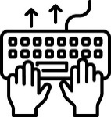  Human does all the writing | Conventional writing, all by human | Human does all the writing | Everything | -- | No usage of AI | --
Table 1-The proposed spectrum of human-AI collaborative technical writing: HAIRS (Human-AI Research-writing Spectrum)

Mental Models and Metaphors
The HAIRS spectrum is supported by two complementary mental models that help researchers calibrate appropriate AI use: the 80/20 rule, AI-assisted top-down writing metaphor. Each illuminates a different aspect of responsible and effective collaboration.

The 80/20 Rule: Strategic vs. Routine Work
The human-AI 80/20 principle posits that AI can efficiently handle approximately 80% of routine, data-heavy, and time-consuming writing tasks—grammar polishing, sentence fluency, structural transitions, formatting—while humans concentrate on the irreducible 20%: strategy, judgment, intellectual synthesis, and quality assurance (Hwang et al., 2024).
This mirrors established organizational models. A manager delegates operational execution to employees while retaining strategic oversight. A supervisor assigns routine tasks to assistants while maintaining responsibility for outcomes. A civil engineer designs infrastructure on paper, then directs builders to execute while monitoring quality and safety.
Analogously, in research writing, the researcher acts as architect: designing the intellectual argument, curating evidence, and directing the flow of ideas. AI acts as executor: translating that design into polished prose. The researcher's cognitive effort concentrates on the 20% where judgment and novelty matter; AI accelerates the 80% of mechanical work. This partnership does not diminish intellectual ownership—it amplifies it, freeing the researcher to think more deeply about ideas rather than wrestling with sentence construction.
With AI handling the "how" (language, formatting, routine drafting), the researcher retains control over the "what" (ideas, synthesis, conclusions) and gains capacity for innovation.

A Best Practice: AI-assisted Top-Down Writing
Top-down writing is an established best practice in technical and academic authorship (Goldbort, 2006; Nguyen, 2014). Rather than writing sequentially from introduction to conclusion, researchers first identify the core idea, then decompose it into progressively smaller components, and only then write at each level. This approach clarifies thinking and prevents drift. It is based on the well-know “divide-and-conquer” metaphor.
The Hourglass Model (Goldbort, 2006), shown in Figure 1(top), illustrates this hierarchy: researchers begin by narrowing from broad context to a specific research question, then expand again through findings and discussion to broader implications (bottom). Adapted for AI-assisted writing, we propose a tree structure where the research idea (innovation) sits at the apex, and the complete written paper resides at the base. Middle levels represent step-wise decomposition of the core idea into sub-ideas, sub-arguments, and section-level components—analogous to a Work Breakdown Structure (WBS) used in project management.
This structure enables strategic AI orchestration. Rather than prompting AI to “write the paper”, the researcher provides AI with:
- The apex: The central research question or contribution
- The tree: A detailed outline breaking the contribution into component claims, evidence, and narrative flow
- The branches: For each section, specific prompts containing the researcher's notes, literature selections, and conceptual direction
AI then drafts at each level, with the researcher steering and validating throughout. This is the “fill-in-the-blanks” approach: the human provides the intellectual architecture; AI fills in prose.
The metaphor is clarifying: The researcher acts as driver (or architect, or civil engineer); AI acts as car (or builder). The driver directs every turn, maintains control, and is responsible for the destination, while car does the work of the actual movement. Similarly, a civil engineer does not lay every brick; but the engineer designs the building, specifies materials and methods, and inspects quality. The execution is delegated to the builders team.
Operationally, this means:
- Level 5 collaboration (Section 4.1) most naturally employs top-down writing: researcher structures the argument hierarchically, then provides detailed prompts—e.g., "For Section 2.1, discuss X with focus on Y, drawing on sources A, B, and C, and connecting to our argument Z."
- Levels 3–4 use lighter top-down scaffolding: the researcher outlines major sections and provides brief guidance per section; AI drafts, researcher reviews and refines.
- Levels 1–2 involve minimal top-down structure: the researcher may give a single prompt or vague direction; AI generates mostly independently, which is discouraged.
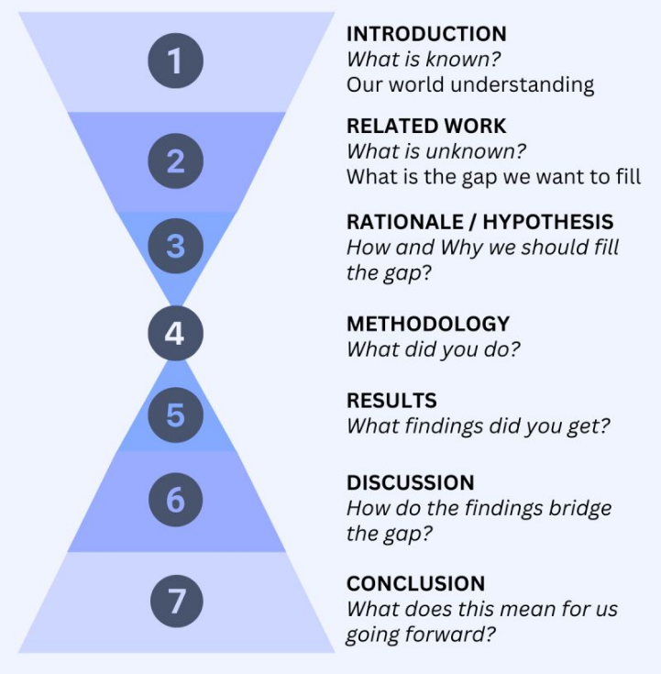

Figure 1-Hourglass model of paper writing, top, adapted from (Goldbort, 2006); and tree structure for AI-assisted research writing (bottom). The tree decomposes the research innovation hierarchically from apex to base, enabling structured AI prompting at each level.
Figure 2 and Figure 3 illustrate the approach: Figure 2 shows how a student's initial draft outline can be refined with AI input; Figure 3 shows a detailed human prompt to Claude for the Introduction section of this current paper, exemplifying the specificity and intellectual direction required at Level 5.
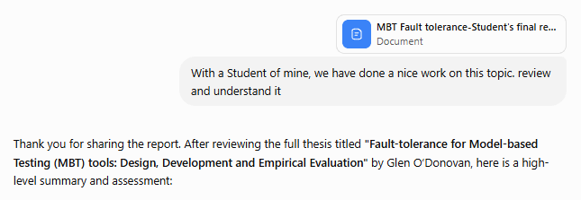
…
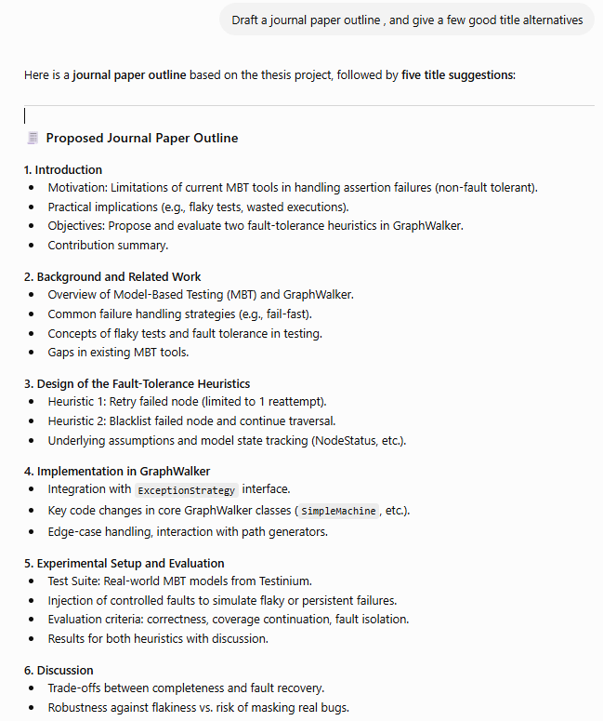
Figure 2-Example of top-down paper writing: A researcher's initial draft outline is provided to Claude for structural feedback and improvement, illustrating the iterative refinement of paper architecture before detailed drafting begins. (structure of sections and sub-sections)
Using my hints below, give text of:

1-Introduction
Context: …
Discuss this Nature paper: How much of the scientific literature is generated by AI? (Naddaf, 2026)
Discuss this grey literature blog: “More Articles Are Now Created by AI Than Humans” https://graphite.io/five-percent/ai-now-writes-as-many-online-articles-as-humans-do
Like “Vibe-coding”, we can call these: “Vibe-research” and “Vibe-writing”.. more precisely, like AI-assisted Software Engineering, we can call these AI-assisted research and AI-assisted research writing.
Problem statement:
Lots of Growing Literature on ethical and responsible AI Use in research, and Academic and Technical Writing
Understanding and characterizing Spectrum and Modes of Collaboration between Human and AI in Research and Technical Writing is important since XXX (you tell me)
Contributions of this paper are X-fold:
• …
•
This article is structured as follows. ……..

------------------
Notes:
--Do not use the Harari style of writing. Use standard academic writing.
--Give text in chat area, not Word file
--Be very concise / minimalistic in text of each part. Paper's total length shall be 8000 words max. keep a count of how much we have written so far.
--Ensure no overlap of the new text that you give, with other parts of the paper.
--Include minimalistic number of in-text citations in APA style , and their full list after each reply that you give. I will integrate them myself using the EndNote Software. Use the references from the list of papers that we already have so far in the paper. If needed, find and cite other minimal number of related papers
-Double check your suggested additional citations to ensure their information are all legit and precise.
Figure 3-Example of detailed human prompt to Claude for Level 5 collaboration (the case of the current paper): The prompt specifies the research question, desired scope, key references, and conceptual framing for the Introduction section, demonstrating the specificity required for highly-mature responsible AI-assisted writing.

Human-AI Collaborative Workflow
The HAIRS framework and its supporting mental models—the 80/20 rule and top-down writing approach—find concrete expression in a structured collaborative workflow. Figure 4 illustrates this workflow as a sequence diagram, showing the dynamic interaction between human researcher and AI across five key phases. Sequence diagram is a modeling notation and one of the model types in the Unified Modeling Language (UML) (Eriksson et al., 2003), showing interactions arranged in time sequence between a number of actions. The collaborative workflow typically includes the following phrases:
Phase 1: Initiation and Idea Sharing. The researcher begins by providing the AI with initial research or paper ideas—as detailed as possible. Rather than a vague prompt (e.g., “write about AI in research”), the researcher supplies context: the research question, preliminary motivation, intended scope, and desired audience. The researcher asks AI for feedback: Does this framing make sense? What related work is missing? How might the argument be strengthened?
Phase 2: AI Feedback and Consultation. AI responds with observations, suggestions for framing, references to related literature, and structural guidance. The AI functions as a knowledgeable colleague offering a sounding board.
Phase 3: Iterative Refinement. The researcher reviews AI's suggestions, incorporates useful ideas, and revises the initial concept. This cycle repeats as many times as needed. With each iteration, the idea becomes clearer, more focused, and better grounded. The researcher retains agency: not all AI suggestions are adopted; the researcher makes final judgment calls.
Phase 4: Collaborative Research Execution. Once the idea is solid, human and AI work collaboratively to gather and analyze secondary data, synthesize literature, and develop arguments. However, a critical boundary applies here: primary data collection (interviews, surveys, experiments, observations) must be conducted by the human alone. The data must reflect the world, not AI's model of the world. AI can assist with instrument design (e.g., survey question wording) and analysis (e.g., coding qualitative data), but collection remains irreducibly human.
Phase 5: Top-Down Paper Writing. With research complete, the researcher applies top-down writing: creating a detailed outline and providing section-level prompts to AI. As illustrated in Figure 2 (Section 4.2.2) and documented in the concrete workflow for Paper P1, the researcher specifies the structure, key arguments, evidence to include, and intellectual direction for each section. AI drafts; the researcher reviews, refines, and validates. This iterative refinement continues until the paper meets the researcher's standards.
Throughout all five phases, the researcher steers and makes final decisions. AI provides rapid feedback, suggestions, and draft text; the researcher filters, selects, and directs. This is Level 5 collaboration in practice: the researcher's cognitive effort focuses on innovation and judgment; AI accelerates mechanical writing work.
The workflow is not linear—researchers often cycle back (e.g., refining research design mid-writing, discovering a need to revisit literature)—but the principle remains consistent: human leads, AI executes, human validates.
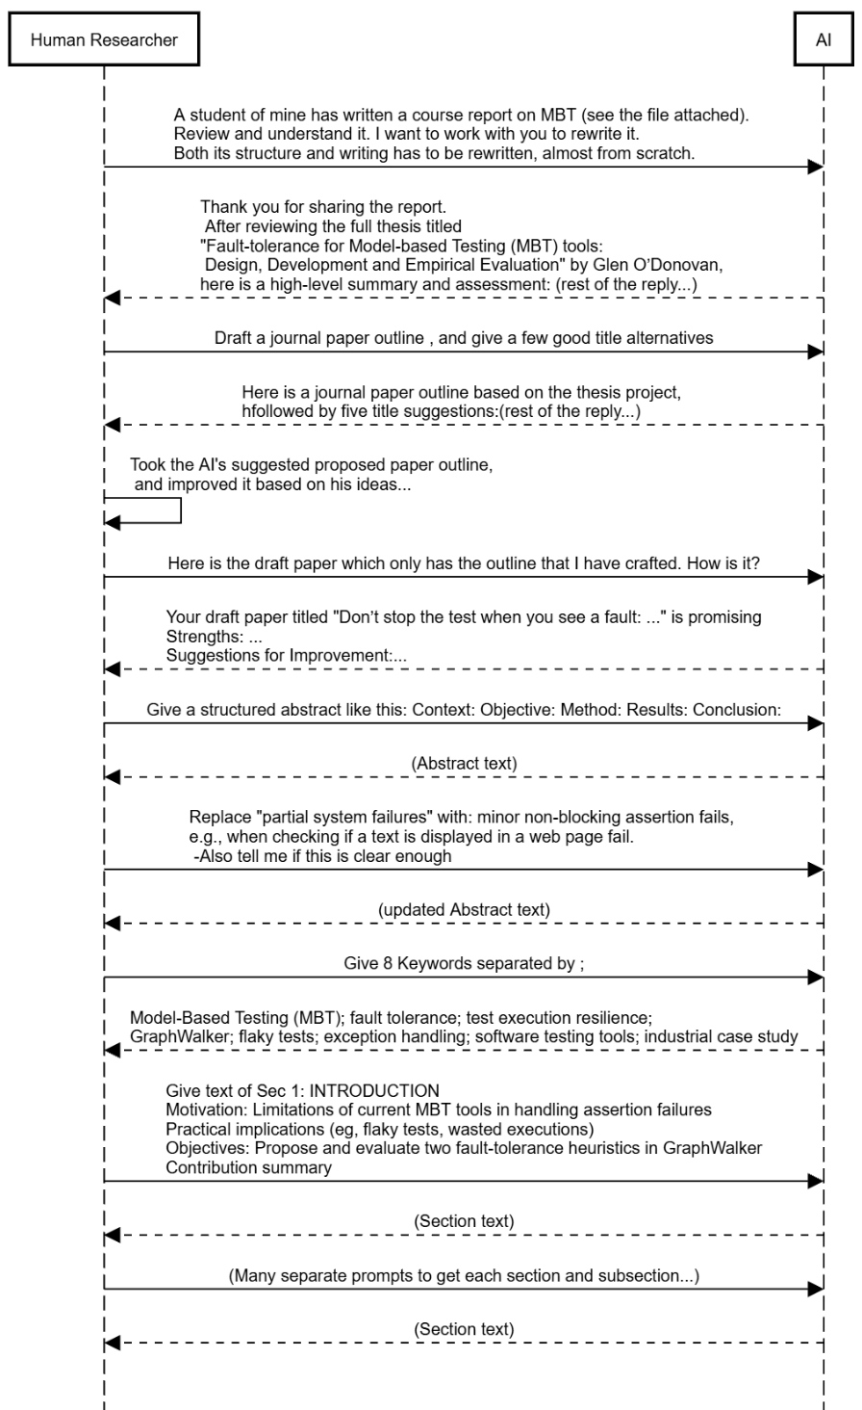
Figure 4- Workflow of human-AI collaborative writing (in the form of a UML sequence diagram), for the case of paper P1: Fault Tolerance for Model-Based Software Testing (to be discussed in Section 5.2.1)

Transparency and Ethical Guidelines
Responsible AI-assisted writing requires explicit disclosure proportional to the level of AI involvement. Table 1 (Section 4.1) specifies disclosure requirements for each level of the HAIRS framework. These requirements translate into concrete practices:
- Level 2 (Proofreading & Grammar) requires minimal disclosure: a brief note such as "Edited with AI grammar tools" suffices, typically in the Acknowledgements. The intellectual substance of the work is entirely human; AI's role is mechanical.
- Level 3 (Structural Refinement) warrants slightly more specificity: "Structural editing with AI" clarifies that AI assisted with coherence and flow, not ideas. Readers understand that the argument and evidence are human-generated; only presentation was refined.
- Level 4 (Collaborative Ideation) requires noting that "AI assisted with outlining and ideation." This disclosure signals that AI provided brainstorming support and structural feedback, but the researcher retained final judgment on research direction.
- Level 5 (Strategic Collaboration) demands the most detailed disclosure: "Strategic human-AI collaboration; researcher owns all ideas and conclusions." This phrasing explicitly states that the researcher provided intellectual direction and retained responsibility for all claims, while AI handled language, formatting, and drafting.
Beyond disclosure, researchers must ensure:
- No fabricated evidence. AI must not generate citations, data, or results. The researcher verifies every claim.
- Human-conducted primary data collection. AI may assist with instrument design or analysis, but data collection remains irreducibly human.
- Researcher ownership of research questions and conclusions. AI may suggest alternatives; the researcher decides.
- Human review of all iterations. The researcher validates accuracy and consistency before publication.
This paper demonstrates Level 5 practice with full transparency: the author provided research direction and iteratively validated all content; Claude assisted with drafting. The Acknowledgements disclose this collaboration in detail.

Illustrative Applications of the Framework
To ground the HAIRS framework in practice, this section reports illustrative applications across six research papers co-developed and co-written by the author using AI assistance. The purpose is not to provide a rigorous empirical study with statistical analysis, but rather to demonstrate how the framework operates in real writing workflows and to extract patterns about efficiency, learning, and best practices.
Each paper represents a natural experiment: varying research domains, authorship structures, AI tools, and timeline. By analyzing these cases, we observe:
- How detailed prompting (Level 5) affects writing efficiency compared to minimal prompting
- How researchers improve their AI collaboration skills across multiple projects
- How team dynamics complicate multi-author AI workflows
- Trade-offs between speed and quality assurance
Data collected include quantitative metrics (writing hours, prompt count, timeline, tool used) and qualitative observations (workflow patterns, iteration cycles, researcher experience). These illustrative cases provide evidence that the framework is operationally viable and yields measurable benefits.

Overview of Illustrative Papers
Text

In all cases, except P1, No previous draft writing of the paper was available, and writing started from scratch. For the case of P1, a MSc student of the author had already written his thesis. Author felt the need to re-write the entire paper.

Table 2 -Illustrative applications of the HAIRS framework across six research papers spanning software engineering, political science, and higher education. Quantitative data include total writing effort (hours), number of prompts issued to AI, tools employed, and timeline. Papers P1–P5 demonstrate various collaboration strategies; P6 (current paper) exemplifies Level 5 strategic collaboration.
ID | Subject (Research area) | Paper topic | # of authors | AI assisted in… |  | AI tool | Date range the paper was written | Estimated effort spent on writing (hour) | Number of prompts given by the researcher to the AI | Notes
 |  |  |  | Research | Paper writing
P1 | Software Engineering | Fault tolerance for Model-Based Software Testing | 4 |  | x | ChatGPT | June-July 2025 | 5,062 minutes ~= 84 hours | 215
P2 | AI, Software Engineering | Hidden Costs of AI-Assisted Software Engineering | 1 | x | x | ChatGPT | July-Aug. 2025 | 3,854 minutes ~= 64 hours | 284 | No previous draft file. Started from scratch
P3 | Caucasus studies, Political Science | Reunification viability of two divided parts of Azerbaijan | 1 | x | x | Claude | March-April 2026 | 1,775 minutes ~= 29 hours | 185 | No previous draft file. Started from scratch
P4 | AI, Software Engineering | Factors influencing the quality of AI-generated code: a Systematic Literature Review (SLR) | 3 | x | x | Claude | March-June 2026 | 2,812 minutes ~= 29 hours | 296
P5 | Higher Education | Developing a causal model for Diagnosing Quality of Higher Education System in Azerbaijan | 1 | x | x | Claude | May-June 2026 | 3,435 minutes ~= 57 hours | 122 | No previous draft file. Started from scratch
P6 | Academic writing | This paper | 1 | x | x | Claude | June-July 2026 | 4,152 minutes ~= 69 hours

Individual Case Insights

Paper P1: Fault Tolerance for Model-Based Software Testing

Paper P2: Hidden Costs of AI-Assisted Software Engineering
done with assistance of ChatGPT
paper2-Log of human-Aİ collaborations

Paper P3: Reunification Viability of two Divided Parts of Azerbaijan
done with assistance of ChatGPT

Paper P4: Factors Influencing the Quality of AI-Generated Code

Paper P5: Developing a Causal Model for Quality of Higher Education System
in Azerbaijan

Paper P6: The Current Paper

Consulting with AI and get its opinion on paper structure… since a high quality paper structure will make the rest of writing easier and result in a better paper. top-down writing approach is a really good one.

Cross-Paper Patterns and Learnings

Speed and Integrity: Efficiency Gains Within Ethical Research Guidelines
Assessing Cost Savings, Ensuring High Quality
At least twice the time without the AI help… based on time log recorded by the researcher for the 150+ paper written by him and his co-authors in the past…

The Learning Curve: Efficiency Gains Across Papers P1–P5
Researcher gradually gaining more experience and getting more effective, between paper #1 and #56

The Multi-Author Challenge: Coordination and Consistency
What will happen when there are multiple co-authors, and they all want to get AI assistance
Things can get confusing and complex, if each co-author wans to get AI assistance in research itself and also in the writing…
By a divide-and-conquer approach is expected to work, but the author have not had any such experience yet. All his multi-author papers have been done and written without AI assistance.

Discussions and Implications

Limitations
Limitations of the proposed Framework
Limitations of the Illustrative Applications

Implications
Implications for researchers
- we separate for junior researchers – researchers in training like PhD students - versus senior researchers
- senior researchers have done many research projects and papers “without” AI assistance, so they know how to do it
- but junior researchers – researchers in training like PhD students, need to learn the whole research and writing by themselves first, so they learn by “Productive Struggle” first (learning theory). Only then, they shall use AI assistance

Implications for journal editors, conference chairs, publishers…?
Implications for other stakeholders?

Conclusions

Acknowledgements
The author used the Claude (Anthropic) AI tool to assist with drafting and structuring this article. The author reviewed, revised, and verified all content, and takes full responsibility for the work.

References
Chugunova, M., Harhoff, D., Hölzle, K., Kaschub, V., Malagimani, S., Morgalla, U., & Rose, R. (2026). Who uses AI in research, and for what? Large-scale survey evidence from Germany. Research Policy, 55(2), 105381.
Dere, O. (2023). Artificial Intelligence Tools in Academic Article Writing: Is it a Tool or a Co-Author? European Journal of Therapeutics, 29(4), 992–993.
Dergaa, I., Chamari, K., Żmijewski, P., & Ben Saad, H. (2023). From human writing to artificial intelligence generated text: examining the prospects and potential threats of ChatGPT in academic writing. Biology of Sport, 40(2), 615 – 622.
Docter-Loeb, H. (2026). Meet the academics refusing to use generative AI. Nature, 653, 971 – 972.
Eriksson, H.-E., Penker, M., Lyons, B., & Fado, D. (2003). UML 2 toolkit. John Wiley & Sons.
Formosa, P., Bankins, S., Matulionyte, R., & Ghasemi, O. (2024). Can ChatGPT be an author? Generative AI creative writing assistance and perceptions of authorship, creatorship, responsibility, and disclosure. AI & SOCIETY, 40, 3405 – 3417.
Goldbort, R. (2006). Writing for science. Yale University Press.
Hassabis, D. (2024). Accelerating Scientific Discovery with AI. The Keio Journal of Medicine.
Heidt, A. (2025). AI for research: the ultimate guide to choosing the right tool. Nature, 640, 555 – 557.
Hwang, A. H.-C., Liao, Q. V., Blodgett, S. L., Olteanu, A., & Trischler, A. (2024). 'It was 80% me, 20% AI': Seeking Authenticity in Co-Writing with Large Language Models. Proceedings of the ACM on Human-Computer Interaction, 9, 1 – 41.
Lee, J., & Park, J. (2023). AI as “Another I”: Journey map of working with artificial intelligence from AI-phobia to AI-preparedness. Organizational Dynamics, 52(3), Article ID: 100994.
Naddaf, M. (2026). How much of the scientific literature is generated by AI? Nature.
Nguyen, L. T. C. (2014). A top-down approach to strategy-based instruction in writing and its impact on components of a writing piece. New Zealand studies in applied linguistics, 20(1), 21.
Porsdam Mann, S., Vazirani, A. A., Aboy, M., Earp, B. D., Minssen, T., Cohen, I. G., & Savulescu, J. (2024). Guidelines for ethical use and acknowledgement of large language models in academic writing. Nature Machine Intelligence, 6(1), 1272 – 1274.
Rentier, E. S. (2024). To use or not to use: exploring the ethical implications of using generative AI in academic writing. AI and Ethics, 5(3), 3421 – 3425.
Samuel, J., Khanna, T., Esguerra, J., Sundar, S., Pelaez, A., & Bhuyan, S. S. (2025). The Rise of Artificial Intelligence Phobia! Unveiling News-Driven Spread of AI Fear Sentiment Using ML, NLP, and LLMs. IEEE Access, 13, 125944–125969.
Samuel, J., Khanna, T., & Sundar, S. (2024). Fear of Artificial Intelligence? NLP, ML and LLMs Based Discovery of AI-Phobia and Fear Sentiment Propagation by AI News. SSRN Electronic Journal.
Tang, B. L. (2025). The Epistemic Downside of Using LLM-Based Generative AI in Academic Writing. Publications journal, 13(1), 63–69.
Winberg, C., Engel-Hills, P., & Winberg, S. (2024). “Am I in Control of My Own Writing?”: Training Postgraduate Candidates in the Responsible Use of Generative Artificial Intelligence in Academic Writing. African Journal of Inter/Multidisciplinary Studies, 6(1), 1–12.
Zhao, L., He, Q., Kamal, M. M., & O’Regan, N. (2025). Technophobia and the manager’s intention to adopt generative AI: the impact of self-regulated learning and open organisational culture. Journal of Managerial Psychology, 40(5), 567–585.

Appendix A-Example Noteworthy Interactions with AI

Asking AI to Review the Paper Structure Drafted by The Researchers for the Case Paper P6 (The Current Paper)
Prompt by researcher (the author) to AI:
“Here is my latest paper structure. Do you have any suggestions to improve or add or remove things?
1 Introduction
2 Background And Related Work
2.1 Emergence of AI and its Use in Different Research Activities
2.2 Growing Literature on AI Use in Academic and Technical Writing
2.3 AI-o-phobia and Ideas of Banning AI Use in Research Writing
2.4 Related Works and Existing Models or Frameworks
2.5 Existing Dedicated AI Tools for Supporting Research and Academic Writing
3 Research Approach
4 Spectrum And Modes Of Human-Ai Collaborative Research And Technical Writing
(rest of the table of contents)
AI’s response:
Good structure overall. You have a solid progression: Background → Framework → Evidence → Guidance → Implications. But I see several alignment issues with your new narrowed title and some structural optimizations:
Major Issues
1. Scope Misalignment (Critical)
Your title is now "Separating Innovation from Mechanical Writing" (writing-focused), but you still have:
- Section 4.1 — "Research itself or Writing? Which one comes First?"
- Section 4.2 — "A Taxonomy of Research Activities"
Both are broader than writing. You mentioned possibly removing 4.2—I'd say remove both, or collapse them into a single subsection:
Option A: Remove 4.1 & 4.2 entirely
- Open Section 4 directly with 4.3 (The Spectrum)
- Add a one-paragraph intro to Section 4 that says: "We focus on technical writing as a discrete, separable phase of research. While writing is embedded in broader research processes, this paper examines the collaboration modes specific to the writing task itself."
Option B: Compress to 4.1 only
- Combine 4.1 + 4.2 into a single section: "4.1 Writing as a Separable Research Activity"
- Very brief (1–2 pages). Say: "Writing is one of many research activities. This paper focuses on writing specifically because (1) it's separable from innovation, and (2) it's where mechanical/routine work concentrates."
- Then jump to 4.3 (Spectrum).
(more suggestions)
Revised Structure (Proposed)
1. Introduction
2. Background and Related Work
3. Research Approach
4. Separating Innovation from Mechanical Writing: A Spectrum of Collaboration
4.1 The Spectrum: Six Levels of Maturity
4.2 Mental Models (80/20 Rule, Pyramid, Driver/Car)
4.3 Collaborative Workflow
4.4 Transparency and Ethical Guidelines
5. Illustrative Applications
5.1 Overview of Illustrative Papers
5.2 Individual Case Insights
5.3 Cross-Paper Patterns and Learnings
6. Best Practices and Anti-Patterns
7. Implications (for researchers, educators, editors, funders, developers)
8. Limitations
9. Conclusions and Future Work
Acknowledgements
What's your take? Any pushback on removing 4.1–4.2?
Prompt by researcher (the author) to AI::
In Sec 5.2, the subsection of individual case insights, shall we have a heading H3 for each of the six papers? Because that's not clear now. Also RE Section 6, I'm thinking of removing it for two reasons. First, if we have it, the paper becomes quite shallow covering too many things, and the focus is going to be slightly lost. Also, the maximum paper lengths that we can go is 9K words. And I believe with all the other parts, it's going to reach that 9K words. So I just removed section six, the patterns and anti patterns of AI-Assisted technical writing, and I will later write another paper on those idea. Give me the updated TOC.
AI’s response:
Perfect decisions. Removing Section 6 keeps the paper focused and under word limit. And yes, H3 headings for each paper make it much clearer. Here's your updated TOC:
- Updated Table of Contents
- Introduction
- Background and Related Work
  - 2.1 Emergence of AI and its Use in Different Research Activities
  - 2.2 Growing Literature on AI Use in Academic and Technical Writing
  - 2.3 AI-o-phobia and Ideas of Banning AI Use in Research Writing
  - 2.4 Related Works and Existing Models or Frameworks
  - 2.5 Existing Dedicated AI Tools for Supporting Research and Academic Writing
- Research Approach
- Separating Innovation from Mechanical Writing: A Spectrum of Collaboration Modes
  - 4.1 The Spectrum: Six Levels of Maturity
  - 4.2 Mental Models and Metaphors
    - 4.2.1 The 80/20 Rule: Strategic vs. Routine Work
    - 4.2.2 The Pyramid: Innovation at Top, Mechanical Writing at Base
    - 4.2.3 The Driver/Car: Human Steers, AI Executes
  - 4.3 Collaborative Workflow
  - 4.4 Transparency and Ethical Guidelines
- Illustrative Applications
  - 5.1 Overview of Illustrative Papers
  - 5.2 Individual Case Insights
    - 5.2.1 Paper P1: Fault Tolerance for Model-Based Software Testing
    - 5.2.2 Paper P2: Hidden Costs of AI-Assisted Software Engineering
    - 5.2.3 Paper P3: Reunification Viability of Two Divided Parts of Azerbaijan
    - 5.2.4 Paper P4: Factors Influencing the Quality of AI-Generated Code
    - 5.2.5 Paper P5: Developing a Causal Model for Quality of Higher Education System
    - 5.2.6 Paper P6: The Current Paper
  - 5.3 Cross-Paper Patterns and Learnings
- Discussion and Implications
  - 6.1 Limitations
  - 6.2 Implications
    - 6.2.1 For Researchers
    - 6.2.2 For PhD Programs and Educators
    - 6.2.3 For Journal Editors and Publishers
    - 6.2.4 For Funding Agencies
    - 6.2.5 For AI Tool Developers
- Conclusions and Future Work

Why This Works Better
✅ Tighter focus — Framework + Evidence + Implications. No dilution.
✅ H3 for each paper — Clear that each has its own takeaway; not a muddled list.
✅ Patterns/anti-patterns → future paper — Smarter academically. Let this paper be definitive on the spectrum; follow-up focuses on guidance.
✅ 9K words fits — Rough estimate:
- Intro + Background: 1.5K
- Research Approach: 0.5K
- Framework (Section 4): 2.5K (mostly tables)
- Illustrative Apps (Section 5): 2.5K (brief cases)
- Discussion + Implications: 1.5K
- Conclusions: 0.5K
- Total: ~9K ✓
This is clean. Ready to start writing?

Alternate name spelling: Vahid Garousi
techcrunch.com/2026/05/16/research-repository-arxiv-will-ban-authors-for-a-year-if-they-let-ai-do-all-the-work
URLs and webpages of these tools can be easily found via a simple internet search
github.com/vgeruslu/modes-of-human-AI-collaborative-writing
Note that this is only the estimated effort (time) spent on writing each paper, as provided by the "document info" feature of Microsoft Word; and not the effort (time) spent on the research component of each paper, as that time was not logged via any manual nor automated mechanism.

